**Problem 3**

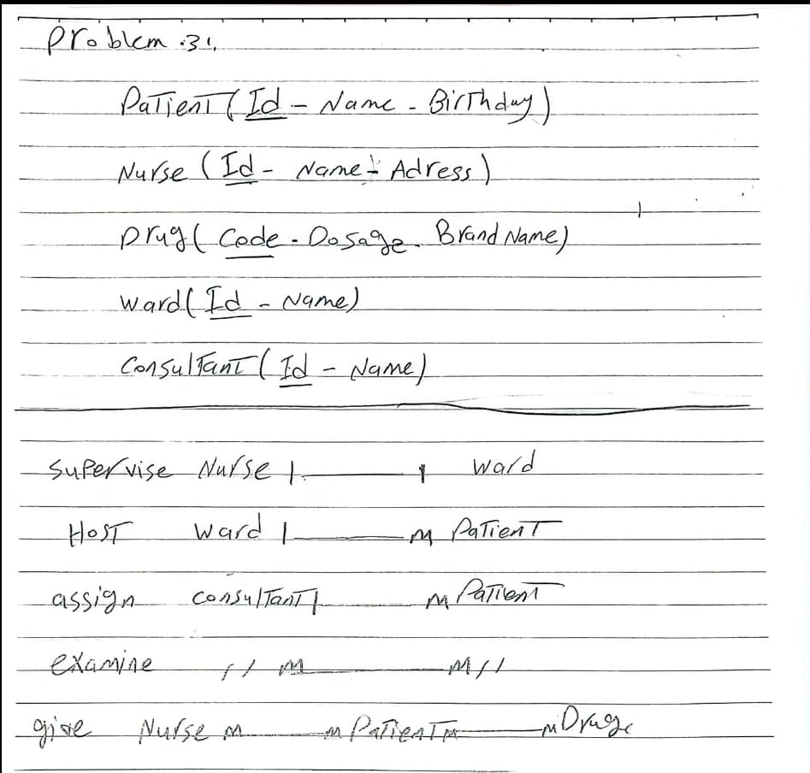

M

M

M

M

M

M

M

1

1

1

1

Hospital tables

1. Patient Table

|  |  |  |
| --- | --- | --- |
| PatientId | Name | Date of birth |
| 1 | ahmed | 17/5/2004 |
| 2 | omar | 1/1/2000 |
|  |  |  |

|  |  |  |
| --- | --- | --- |
| code | Dosage | BrandName |
| 1 | 2 | asdas |
| 2 | 6 | asdas |
|  |  |  |

1. Nurse Table

|  |  |  |
| --- | --- | --- |
| Id | Name | Adress |
| 1 | alaa | Cairo |
| 2 | samr | 1/1/2000 |
|  |  |  |

1. Ward Table

|  |  |
| --- | --- |
| Id | Name |
| 1 | ahmed |
| 2 | Ashraf |
|  |  |

1. Drug Table

1. Consultant Table

|  |  |
| --- | --- |
| Id | Name |
| 1 | ahmed |
| 2 | Ashraf |
|  |  |